Press release

Leading Social Enterprise Micro Rainbow named in NatWest SE100 Index and calls for more LGBTQI social enterprises to come forward.

On 12th July 2024 Micro Rainbow was crowned one of the top 100 social enterprises in the UK in the NatWest SE100 Index 2024. At the awards ceremony held on 16th July, Micro Rainbow’s Founder and CEO, Sebastian Rocca, was also named Pioneering Leader of the Year.
Sebastian Rocca, said:
“We are thrilled to be named one of the top 100 social enterprises for the fourth year in a row. In 2023 we supported over 1,100 LGBTQI fleeing persecution. It’s fantastic to see Micro Rainbow recognised for its hard work and innovative vision. It’s a crucial reminder that despite the current rhetoric around refugees and LGBTQI people, the vast majority of people are welcoming to refugees and support LGBTQI people. We are proud to be a social enterprise that changes LGBTQI lives.”
Sebastian also added:
“We are proud to be one of the top 100 social enterprises in the UK. At the same time, we would like to see other LGBTQI mission led social enterprise join the list. That would further transform our movement and enable us to more effectively meet today’s challenges.
I believe social enterprises can play a crucial role in responding to the rise of LGBTQ+-phobia, but we need to step up our game. A business model such as a social enterprise has the potential not only to increase funding for our movement but also to make it more sustainable”.
For further information or images please contact: media@microrainbow.org

Notes
- Read Sebastian’s full opinion piece We need more LGBTQ+ social enterprises – here’s why

- About Micro Rainbow. Founded in 2012 Micro Rainbow is the leading not for profit organisation in the UK supporting the integration of lesbian, gay, bisexual, trans, queer and intersex (LGBTQI) people who flee persecution and reach the UK in search of safety. Micro Rainbow’s holistic approach to integration is based on three pillars: safe housing, social inclusion, and employability support. These programmes ensure that LGBTQI refugees are not only safe but also able to live fulfilling, independent lives. Micro Rainbow has won several awards for innovation and as a top social enterprise and is recognised for creating the first ever national safe housing scheme for LGBTQI people fleeing persecution, with a capacity of 30,000 bed-nights a year. Micro Rainbow is committed to eradicating the homelessness of people fleeing persecution in the UK. It continues to raise social investment to make that happen. Find out more at: www.microrainbow.org

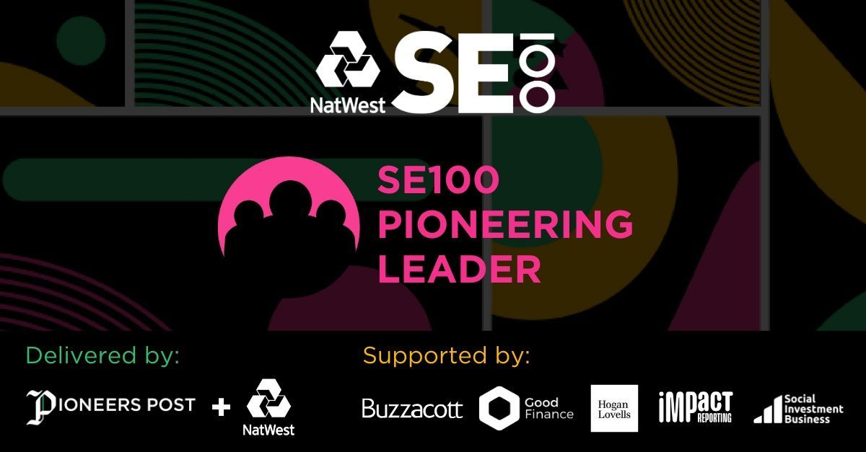

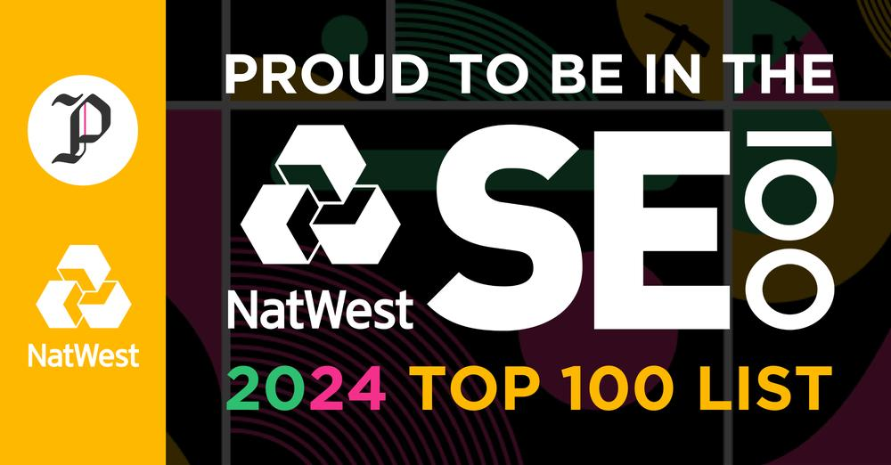

The NatWest SE100 Index was devised in 2010 by Pioneers Post and NatWest to recognise and reward the leading 100 social enterprises across the UK each year. The Top 100 are judged on a wide range of criteria – from the growth and sustainability of their businesses to the innovation and resilience they have demonstrated and the social impact they have delivered.
The Pioneering Leader Award recognises social enterprise bosses demonstrating excellent leadership, effectiveness and inspiration in taking the team on a mission-driven journey to success. Sebastian was awarded this prize alongside Lisa Stapanovic, founder of Social Ark, an organisation that helps young people bring their start-up ideas to life.

